Name: Richard Raymond J. Canda

C.Y.S.: BSCpE - 3A

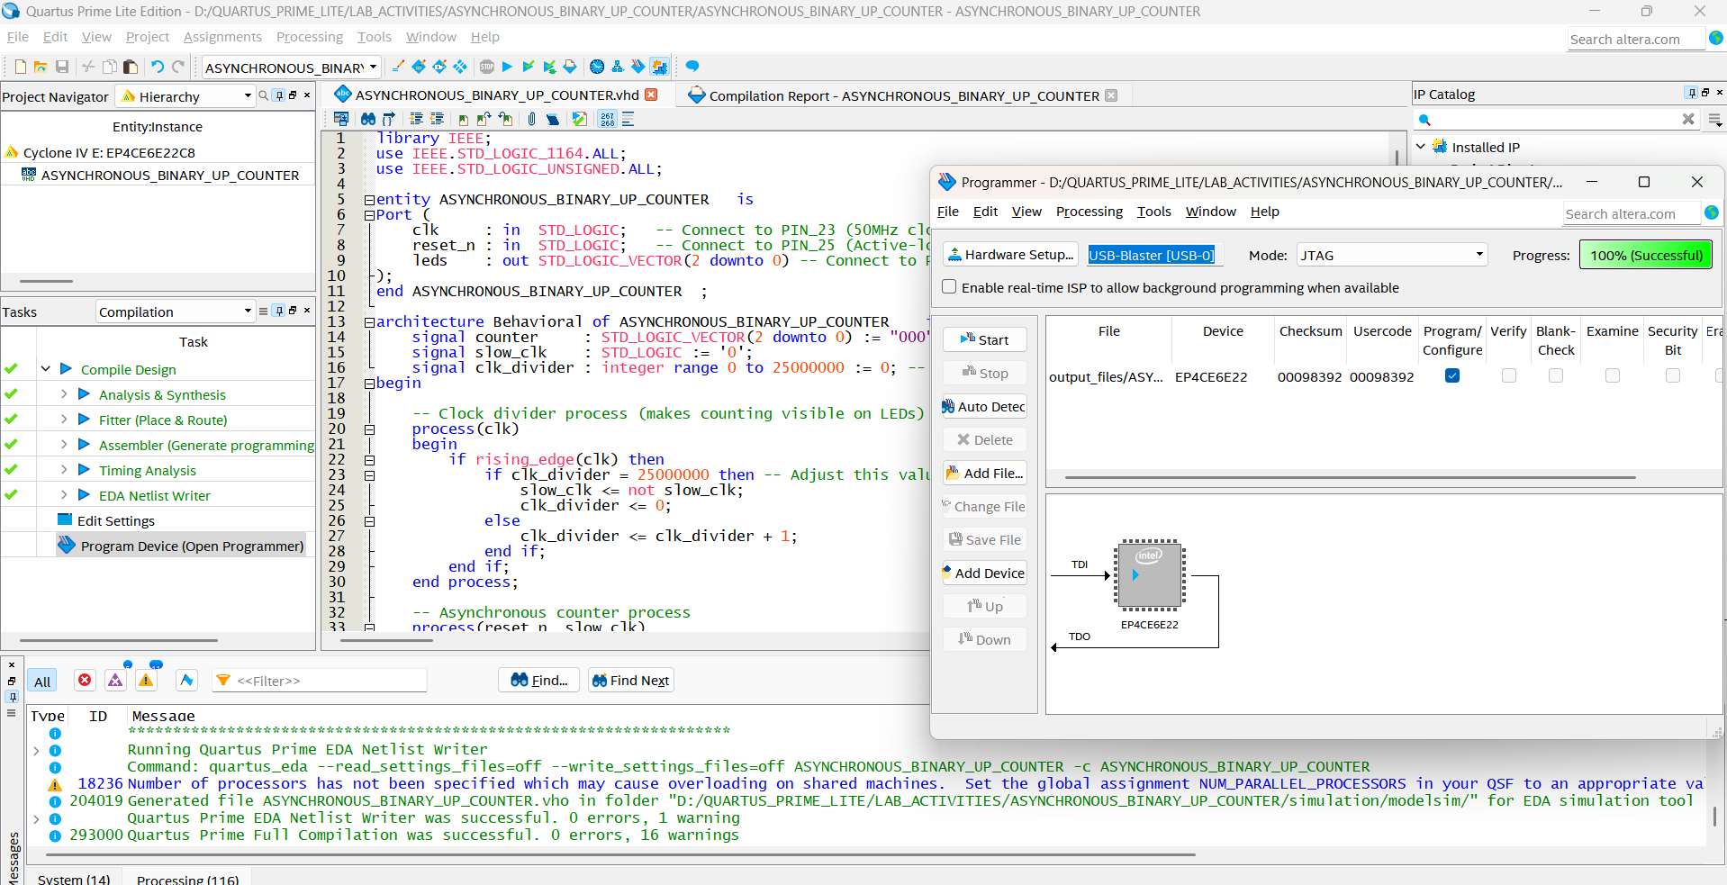

**ASYNCHRONOUS BINARY UP COUNTER**

library IEEE;

use IEEE.STD_LOGIC_1164.ALL;

use IEEE.STD_LOGIC_UNSIGNED.ALL;

entity ASYNCHRONOUS_BINARY_UP_COUNTER is

Port (

clk : in STD_LOGIC; -- Connect to PIN_23 (50MHz clock)

reset_n : in STD_LOGIC; -- Connect to PIN_25 (Active-low reset button)

leds : out STD_LOGIC_VECTOR(2 downto 0) -- Connect to Pins 87,86,85

);

end ASYNCHRONOUS_BINARY_UP_COUNTER ;

architecture Behavioral of ASYNCHRONOUS_BINARY_UP_COUNTER is

signal counter : STD_LOGIC_VECTOR(2 downto 0) := "000";

signal slow_clk : STD_LOGIC := '0';

signal clk_divider : integer range 0 to 25000000 := 0; -- For 1Hz @ 50MHz

begin

-- Clock divider process (makes counting visible on LEDs)

process(clk)

begin

if rising_edge(clk) then

if clk_divider = 25000000 then -- Adjust this value for speed

slow_clk <= not slow_clk;

clk_divider <= 0;

else

clk_divider <= clk_divider + 1;

end if;

end if;

end process;

-- Asynchronous counter process

process(reset_n, slow_clk)

begin

if reset_n = '0' then -- Active-low reset

counter <= "000";

else

-- First stage (LSB)

if rising_edge(slow_clk) then

counter(0) <= not counter(0);

end if;

-- Second stage

if falling_edge(counter(0)) then

counter(1) <= not counter(1);

end if;

-- Third stage (MSB)

if falling_edge(counter(1)) then

counter(2) <= not counter(2);

end if;

end if;

end process;

-- Active-high LED outputs (invert if your board needs active-low)

leds <= counter;

end Behavioral;

